EXPERIMENT 7

15BCE0517

M.S.SANJAY

**1)**

> n1=900

> mu1=0.20

> n2=1600

> n1=900

> p1=0.20

> n2=1600

> p2=0.15

> P=((n1*p1)+(n2*p2))/(n1+n2)

> Q=1-P

> z=(p1-p2)/sqrt(P*Q*((1/n1)+(1/n2)))

> z

[1] 3.209704

> alpha=0.05

> z.alpha=qnorm(1-alpha/2)

> z.alpha

[1] 1.959964

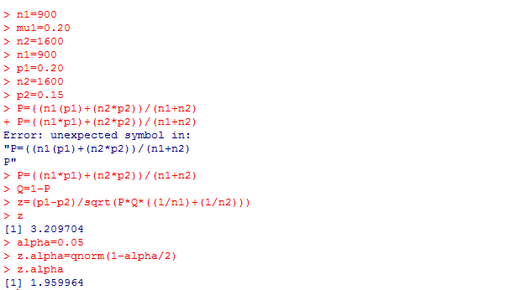

**Inference-:**

***The z calculated value has more than the z tabulated by this we can conclude that the null hypothesis is rejected and there is a significant difference between both population averages so alternate hypothesis accepted.***

***2)***

> n1=200

> p1=42/200

> n2=100

> p2=18/100

> P=((n1*p1)+(n2*p2))/(n1+n2)

> Q=1-P

> z=(p1-p2)-(0.08)/sqrt(P*Q*((1/n1)+(1/n2)))

> z

[1] -1.02993

> alpha=0.05

> z.alpha=qnorm(1-alpha/2)

> z.alpha

[1] 1.959964

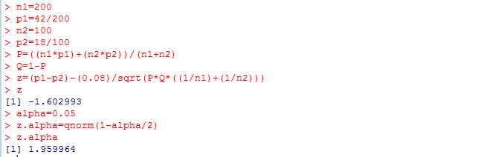

**Inference-:**

***The mode z value is less than the z tabulated value means the null hypothesis is accepted and alternate hypothesis rejected means p1-p2=0.08 is a valid claim.***